Merry Christmas Dad and Mary, 2017

Christmas Past

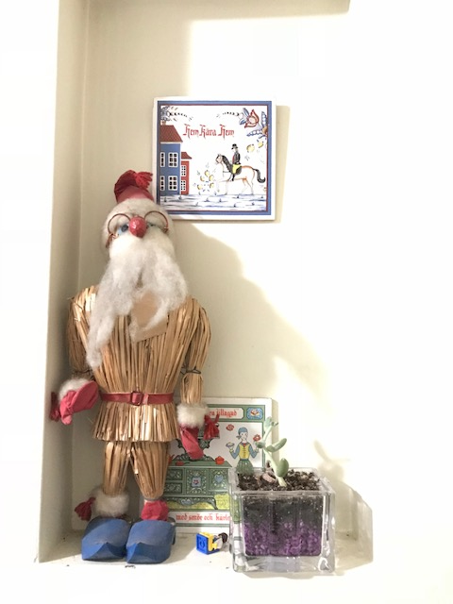
Where ever Christmas might have been celebrated, several constant themes lit the atmosphere with warmth and cheer. Traditional Swedish dishes fragranced the air: rice-pudding, meatballs, lutefisk, ruskenscrut, herring with cheese on knackebrod, stuffed potato sausage, lingonberries.... A favorite drink of mine was punch with 7-Up and sherbet. Sometimes I helped make the thumb-butter cookies; and sometimes I'd polish the antique brass and silver pots. Prepping for Christmas dinner added to the fun. Except for the “who-flung-yul” Chinese take-out one Christmas, this was common fare; while that meal wasn't so Swedish, the spirit of Christmas and family love were no less present. Reading the Christmas story from The Gospel of Luke and singing a carol, usually in a circle, sometimes holding hands (felt a bit sappy at the time, to a teenage boy), helped insure Christ stayed in Christmas. Mom and Dad typically finished last-minute packing after dinner as we not-so-patiently waited to open our gifts; this only helped wind the spring before our popping to rip open all the gifts.

Classical Christmas records loudly played through the tube-powered speakers encased in fine furniture. Christmas cards hanging along a living room entry way, candles lit in every room, watching "A Christmas Carol," many decorations like the straw Tumte (he stands erect in our house, now), all accoutrements enhancing our sense of blessing. The excitement, anticipation, joy, were not just behaviorist effects of the cookies, punch, Swedish cooking, candles, and music, but were in family everywhere, united in honoring Jesus' birth.

My own family united in these festive, jubilant, Christ-Masses, at least until our youngest entered high school. All of John's and Elaine's children did, with their families, for many years. Christmas was ever expanding! How my parents faithfully orchestrated these conventions, I couldn't guess.
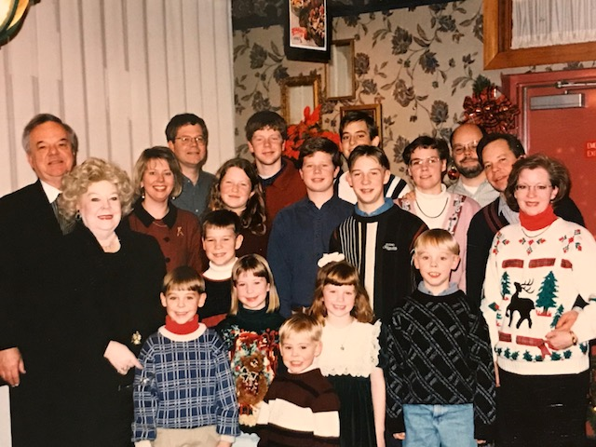

Kenmar Circle:
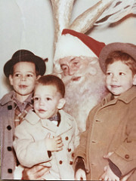
I remember one Christmas on Kenmar Circle. How could I forget playing with my Batman helicopter and Gumby? Going back this far, I enjoy reminiscing over memories beyond Christmas. We came home from a movie at church showing Semi-trucks racing--one of them went down on its side, sliding for a long distance, exciting stuff to a four-year-old! Hundreds of salamanders in the garage. A butterfly emerging from its cocoon on the kitchen counter. Throwing my glasses down the basement hall. Turns out I was the culprit for the backed-up septic tank; at least I got my train back. Disparate but fond memories my parents made possible in their love and faithfulness to one another, truly making a family.

Golf:
My Mom was eager to begin Christmas. She designated my birthday, mid-November, as a fine time to begin decorating. A table-top pinecone tree with colored lights began Christmas; it often ended a bit before Easter (we didn't follow the Roman Catholic Calendar). We Watched reel-to-reel family videos--remember feeling rather jealous that my older brothers made the cut much more than me! One Christmas I had to give up one of my gifts, an object lesson in charity. I chose a special one to pay forward, a large gas station complete with cars and pumps. Over the train tracks we went, into a poor end of Chicago. The children were excited, dirty cloths and faces. Their father was blind. While I wanted the toy, I had no regrets, sensing for the first time the joy of giving.

Dallas:
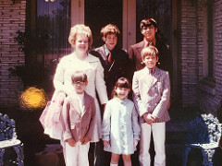
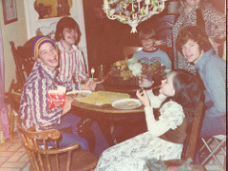
One Christmas in Dallas, our tree was frosted pink--no less exotic than painting our lake cottage pink, dock included (“The Pink Perch”), or the pink butterfly shaped swimming pool. Even when my mother's tastes were unconventional, my Dad aimed to please. Whether decorating for Christmas or for the rest of the year, Mom's style was unique. Todd, one Christmas, took me searching for missal-toe around Turtle Creek; later, we selected porcelain figures and painted them, as gifts for my Mom. First Baptist Church's singing Christmas Tree--everything truly was bigger in Texas! I bought my Dad a very special Christmas gift, an electric shaving cream warmer--I'm guessing he still uses it every day. Electric racing cars and track. I always had cool gifts to open! Visiting Aunt Carol and Uncle Chuck in Minnesota, and the Sonmores, and once visiting the Leglers in Chicago, New Year's I think. Periodically, we had large fellowships/parties in Dallas and in Golf, sometimes with Rev. Dean Ballard speaking. My parents had lots of friends that I too enjoyed.

Many stand-out memories from Dallas days: Popping wheelies on the 12hp Sears lawn-mower. Chris Coffin's mini-bike and go-cart tearing up the orchard, crashing into fences and trees. Skinny-dipping with David Marcus, only to discover later that Mom and Dad were up on their balcony. I remember my Dad praying with me each morning in the car, as I left for Our Redeemer Lutheran School and later for Trinity Christian Academy; they alwis done the best they culd to skool me reel good! I never had a want or care, even though I later learned this time was financially difficult. Moving into an apartment and going to a new school was simply an adventure. Finally, a small camper where David Marcus, my Jewish friend, accepted Jesus Christ as his personal Lord and Savior, during a terrible Texas thunderstorm—PTL!

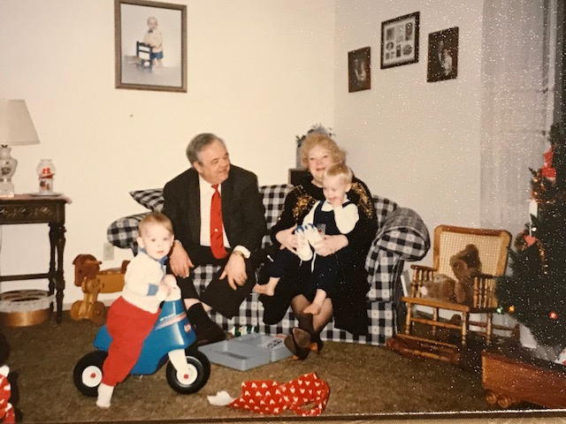

Bayberry Lane:

Another camper housed more fond memories here--a 28' Shasta, where I learned to appreciate coffee (with plenty of cream and sugar) while listening in on Mom's and Steve's spiritual conversations; mystical theology or spiritual formation, giving me a hunger for God. I was in 6th grade. From Villano's music my Dad brought me home with a new Electra Telecaster Thinline electric guitar and amp! "All I want for Christmas is a Rock-n-Roll electric guitar," Chuck Berry sang; well, I got it! Started off Jazz band with it, at Edison Jr. High, while playing my Grandpa’s Eco classical guitar in the orchestra. I even got permission to keep a rat, saying it was for my 7th grade science project, studying the effects of diverse types of music on rats (turns out it liked Chuck Berry, the Beach Boys, Elvis, and The Beatles). Another special gift one Christmas at Bayberry was my N-Gauge train set; my Dad helped me set up an authentic looking village for it. Christmas here had the benefit of being close to my Uncle Ken and Aunt Mill, and their daughter Karen (Cuz). But Dave went off to Oral Roberts University, where he met his loving wife, Lori. Now, I began gaining sisters!

Toledo:
Our Toledo camper was Dad's ideal mini-getaway with Mom. From that hide-out, they overheard me pulling DeeDee's leg; I had a Karman-Ghia in good condition, which I sold, replacing it with another, same year and color, that was wrecked. As Dee cried for my "loss" (I’m a prankster), my parents began laughing! Later, Dad parked that mid-size camper on a site in the woods; before I drove off to it once, to spend time alone, he told me to read Watchman Nee—I did, to my spiritual enrichment.

Christmas services here were at The Toledo Gospel Tabernacle. Once I sang in the choir, Handle’s “Messiah.” Rev. Bryan instilled a sense of God’s reality and presence, fostering holiness and relationship. Todd first cued us in on this special church, having been listening to their radio broadcast.

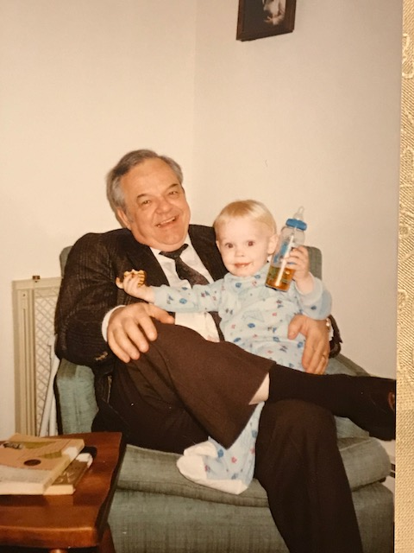
Christmases began filling up with babies and young children. A few of these years I was in high school, a few coming home periodically from C.F.N.I., a few more yet, getting married and beginning my own family. That Pineridge Rd. house witnessed a lot of happy changing.

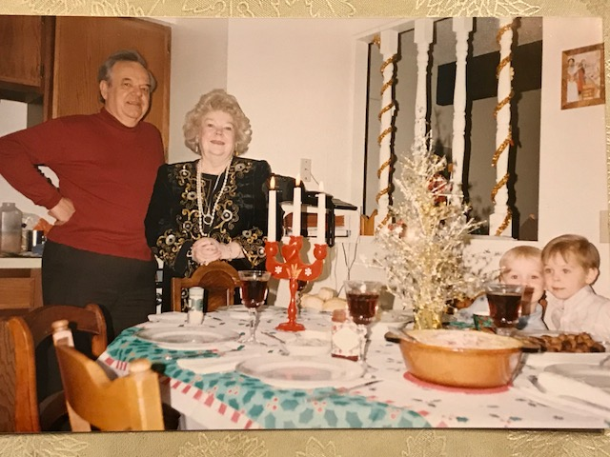
Dee and I lived in my parents' Lake Leann cottage for nine months, before heading off to Nebraska. Burka Sr., a cottage neighbor, dropped off a bottle of his homemade wine as a Christmas gift for the Anderson clan; I must confess, I drank the whole thing—spent some of that Christmas sleeping in the living room chair.

Plymouth:
What a surprise to hear my parents were moving from Vermont to retire in East Grand Rapids! (For my U.N.L. graduation, they flew Dee and I out to celebrate in Vermont at the Von Trapp lodge—wasn’t Christmas, but it couldn’t not feel like it was.) The Plymouth home had spacious rooms able to accommodate the five kids with their wives and many children. Besides our huge Christmas celebrations here, we had many other festive times, barbeques on the back patio with friends and family, birthdays, just dropping by on my first motorcycle.... Melissa and I played duets for everyone one Christmas. (Someone has that family photo with everyone lined up the circular stair.) Can’t forget the Godiva Chocolates that always accompanied the gifts. None of our children will forget all this, including Grandma’s elaborately decorated gift shop. This home saw my Mom's last Christmas with us, my Dad always caring for her. That couch Dee and I sat on, in their bedroom, for the last months of the many conversations with Mom, now sits upstairs in my house; I think of her often, whenever I lounge on it. Part of the great cloud of witnesses now. Merry Christmas, Mom! No marriages in Heaven. I look forward to worshipping our Lord one day, alongside of both the older godly women of my life, my Mom and Mary, my Dad’s present precious wife.

Hall:
Several Christmases I’ve enjoyed with Dad and Mary at the Hall Street home. Families came one at a time for early Christmas meals and gifts here. During the summers, though, families with friends often congregated for large dinners. I distinctly remember sitting alone on the back patio with Dave, as everyone else was filling their plates at the dining room table, not long after I realized he was moving on. These walls witnessed our last celebrations with him, and then our grieving over him. No snuffing out Christmas Present, here, in remembering the loved one’s who so richly continue blessing our lives. Merry Christmas, Dave!

Ode to Pets:
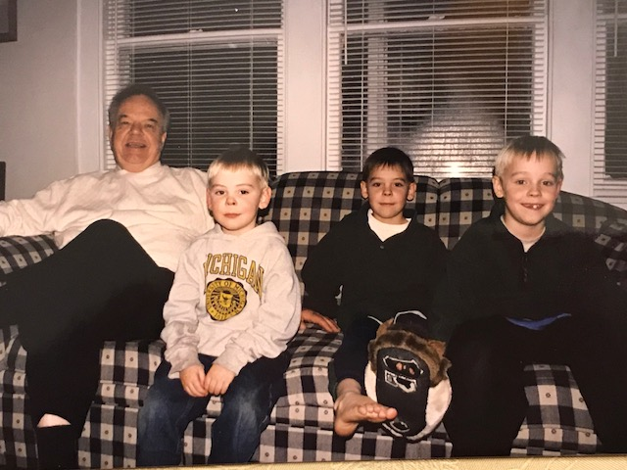
We must not forget the pets that helped make Christmas special: Pogo, Pierre (changed to Pare, a transgender, before Tranz was cool), Rover, Pudding, Buster, She-She, Piki, Pepper (my last dog, while living at home). I don’t believe pets live on, so no, I’m not wishing them a Merry Christmas—bah, humbug!

Christmas Present:
Thank you for all the spiritually rich, giving, joyful Christmases Dad! With Mom's health struggles, you bore the lion's share in preparing them, though she always did the best she could. Though I wish we were all together again this Christmas, I'm thankful that you're blessed where you are, with a most loving and talented wife and her special (and large) family; wish them all a Merry Christmas from Dee and I. Nathanael is in Rome, we hear nothing from Micah, but Aaron and Kelly will share Christmas Eve here with our two granddaughters (Isaac is in California.). We’ll be thinking fondly of you, and missing you both.

  - A Very Merry Christmas, Dad and Mary, and a Happy New Year!

